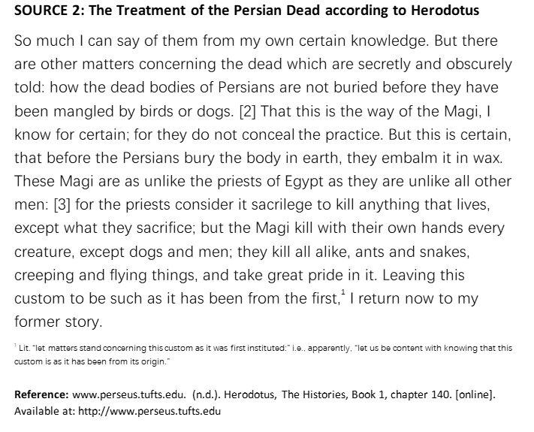

Zoroastrianism:

Zoroastrian excarnation: exposure of human corpses to the elements for the purpose of enabling their decomposition. Carrion birds, usually vultures and other scavengers, consume the flesh. Skeletal remains are gathered into a central pit where further weathering and continued breakdown occurs.

Magi: Priests of the Zoroastrian religion.

Herodotus: Greek author/historian,